Snigdha Gurram
ENVS 185
29 October 2023

CEQA Appendix G:
Environmental Checklist Form
Initial Study
4553 and 4653 North First Street, San Jose,CA, 95134
Planning Department Case No. PD21-016

- Project Title:
Second Harvest Foodbank Warehouse Project

- Lead Agency Name and Address:
City of San Jose
Department of Planning, Building, and Code Enforcement
Cassandra van der Zweep, Supervising Planner
200 East Santa Clara Street
San Jose, CA 95113-1905

- Contact person and phone number:
Snigdha Gurram
408-913-0227

- Project location:
4553 and 4653 North First Street,
San Jose, CA, 95134

- Project sponsor's name and address:
David Andris
South Bay Development Company
475 Alberto Way, Suite 150
Los Gatos, CA, 95032

- General plan designation:
Combined Industrial Commercial (CIC)

- Zoning:
A(PD) Planned Development (PDC99-054)

- Description of project: (Describe the whole action involved, including but not limited to later phases of the project, and any secondary, support, or off-site features necessary for its implementation. Attach additional sheets if necessary.)
This project is in Alviso, CA which is in northern of San Jose. In is located on the west side of North First Street and above the 237 highway. The site is surrounded by many office building and commercial buildings. There is also a residential area to the northwest of the project site as well as a school with a community center and a park in the same direction but a little closer to the project site. There are two more plots of empty land near the site and the Guadalupe River that goes below it to the south of the project site.
This project helps to put in the final pieces of the development of Cisco Site 6 campus to build two office building that are around a total of 249,230 square feet on a 10.47 acre land. The total zoned site is 152.6 acres for 2.325 million square feet for various buildings. The warehouse would take up 209,603 square feet and the office space would take up 39,627 square feet. This project would be consistent with the zoning and General Plan that is already in place for the area.
There is 161 parking spots and 25 truck parking spots built for both trucks and cars along with 35 truck loading docks. There are bicycle paths and lanes for bicycles to be ridden on that already exist in the project site beforehand. For the project site to be out of the flood zone, the project imported about 14,600 cubic yards of soil to raise the project site by a foot so that it is out of the flood zone area.
With the project site being in an open and empty area, this is a place for many creatures and plants to live in this area for a long time. There are around 71 different species in the project site that can be affected by the impacts of the project taking place. A few of the species are also in danger of being extinct or have already gone extinct. If there where trees on the site, they would have to replace them but since there are none this would not take place.
This project would provide jobs for about 815 employees in the office building part of it and about 125 employees for the warehouse part as well as 157 volunteers that would be able to be a part once the site is built. This would provide an estimated 1097 people with jobs.

Table 1. 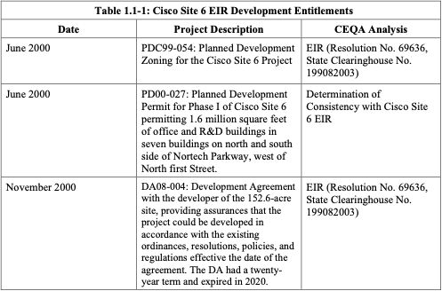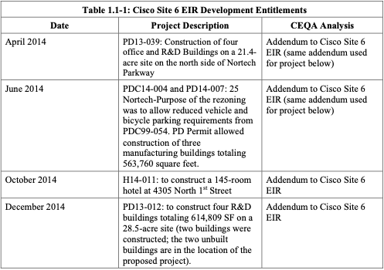
Note. This table shows the time frame of the development the project site went through, describes what the project site went through at that time, and any CEQA analysis that was found.
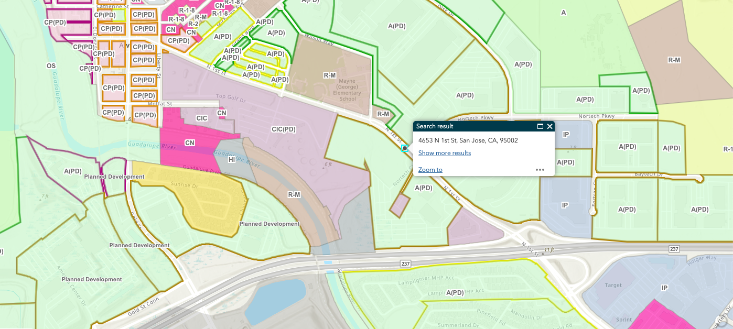
Figure 1. The zoning Second Harvest project site.

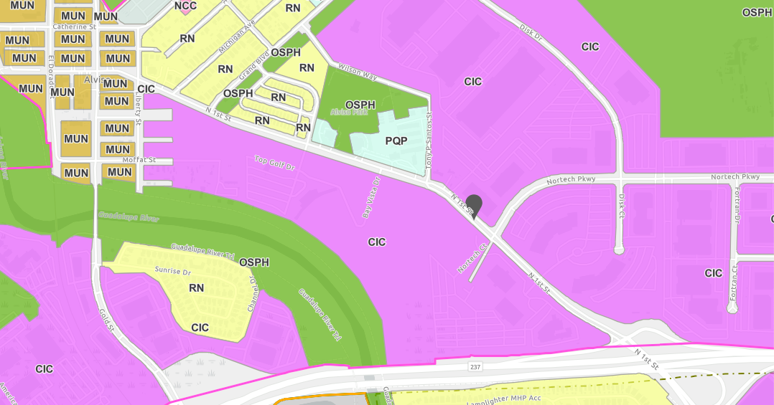
Figure 2. The general plan for Second Harvest project site.
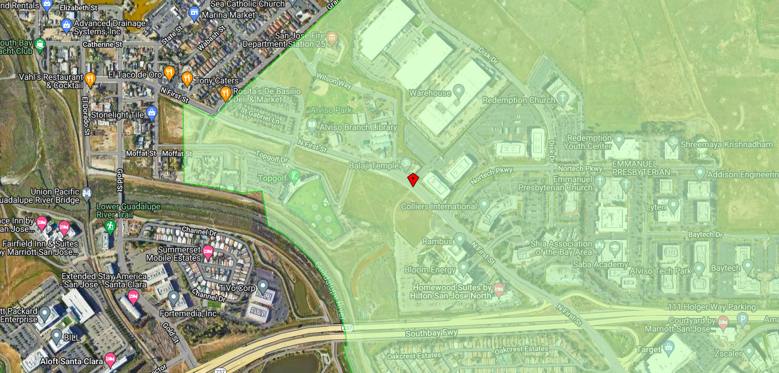
Figure 3. The HCP for Second Harvest project site.

Table 2.
Table 2: Buildings Layout?
 | Building Square Feet | Floors Stories | Number of Parking Spaces (Trucks and Cars) | Truck Loading Docks | Cars | Bikes Parking
Area 1 | 106,364 sq ft | 41 feet above ground at top of roof-47.5 feet above ground at top of roof screen | 94 spaces | 9 docks | 75 spots | 0 parking
Area 2 | 103,239 sq ft | 41 feet above ground at top of roof-47.5 feet above ground at top of roof screen | 113 spaces | 16 docks | 80 spots | 1 parking
Total | 249,230 sq ft | 41 feet above ground at top of roof-47.5 feet above ground at top of roof screen | 207 spaces | 25 docks | 161 spots | 1 parking
Note. This table shows the building square footing, how tall it is, and the number of parking spaces it has for trucks, cars, and bikes allocated to each area.

- Surrounding land uses and setting: Briefly describe the project's surroundings:
The surrounding area are mostly commercial and office building with one residential area, a school with a community center and park. As well as a little bit of open space nearby it. There is a highway, highway 237, going somewhat near the site to the south and the Guadalupe River that is even closer to the site area but in the southwest of the project site.

- Other public agencies whose approval is required (e.g., permits, financing approval, or participation agreement.)
Planned Development Permit permitted 1.6 million square feet for the project during Phase 1 in June 2000 then in November 2000 the city worked with the Development Agreement to work on the 152.6 acres of the project site to confirm that the site would follow the conditions that are already in place. Next in November of 2013 the Planned Development Permit called for constructing on about 614,809 square feet of the project site on 28.5 acres of the 152.6 acre site. They need the local agencies to co permit to regulate the stormwater waste to the municipalities. Local agencies also must enforce the hazardous material regulations. There was a cultural resource record that was done by the Northwest Information Center
- Have California Native American tribes traditionally and culturally affiliated with the project area requested consultation pursuant to Public Resources Code section 21080.3.1? If so, is there a plan for consultation that includes, for example, the determination of significance of impacts to tribal cultural resources, procedures regarding confidentiality, etc.
SKIP

ENVIRONMENTAL FACTORS POTENTIALLY AFFECTED:
The environmental factors checked below would be potentially affected by this project, involving at least one impact that is a “Potentially Significant Impact” as indicated by the checklist on the following pages.

Biological Resources
Land Use/Planning

DETERMINATION: (To be completed by the Lead Agency)
On the basis of this initial evaluation:
I find that the proposed project COULD NOT have a significant effect on the environment, and a NEGATIVE DECLARATION will be prepared.
I find that although the proposed project could have a significant effect on the environment, there will not be a significant effect in this case because revisions in the project have been made by or agreed to by the project proponent. A MITIGATED NEGATIVE DECLARATION will be prepared.
I find that the proposed project MAY have a significant effect on the environment, and an ENVIRONMENTAL IMPACT REPORT is required.
I find that the proposed project MAY have a "potentially significant impact" or "potentially significant unless mitigated" impact on the environment, but at least one effect 1) has been adequately analyzed in an earlier document pursuant to applicable legal standards, and 2) has been addressed by mitigation measures based on the earlier analysis as described on attached sheets. An ENVIRONMENTAL IMPACT REPORT is required, but it must analyze only the effects that remain to be addressed.
I find that although the proposed project could have a significant effect on the environment, because all potentially significant effects (a) have been analyzed adequately in an earlier EIR or NEGATIVE DECLARATION pursuant to applicable standards, and (b) have been avoided or mitigated pursuant to that earlier EIR or NEGATIVE DECLARATION, including revisions or mitigation measures that are imposed upon the proposed project, nothing further is required.
 |  | September 21, 2023
Signature |  | Date
 |  | September 21, 2023
Signature |  | Date
EVALUATION OF ENVIRONMENTAL IMPACTS:
1) A brief explanation is required for all answers except "No Impact" answers that are adequately supported by the information sources a lead agency cites in the parentheses following each question. A "No Impact" answer is adequately supported if the referenced information sources show that the impact simply does not apply to projects like the one involved (e.g., the project falls outside a fault rupture zone). A "No Impact" answer should be explained where it is based on project-specific factors as well as general standards (e.g., the project will not expose sensitive receptors to pollutants, based on a project-specific screening analysis).
2) All answers must take account of the whole action involved, including off-site as well as on-site, cumulative as well as project-level, indirect as well as direct, and construction as well as operational impacts.
3) Once the lead agency has determined that a particular physical impact may occur, then the checklist answers must indicate whether the impact is potentially significant, less than significant with mitigation, or less than significant. "Potentially Significant Impact" is appropriate if there is substantial evidence that an effect may be significant. If there are one or more "Potentially Significant Impact" entries when the determination is made, an EIR is required.
4) "Negative Declaration: Less Than Significant With Mitigation Incorporated" applies where the incorporation of mitigation measures has reduced an effect from "Potentially Significant Impact" to a "Less Than Significant Impact." The lead agency must describe the mitigation measures, and briefly explain how they reduce the effect to a less than significant level (mitigation measures from "Earlier Analyses," as described in (5) below, may be cross-referenced).
5) Earlier analyses may be used where, pursuant to the tiering, program EIR, or other CEQA process, an effect has been adequately analyzed in an earlier EIR or negative declaration. Section 15063(c)(3)(D). In this case, a brief discussion should identify the following:
a) Earlier Analysis Used. Identify and state where they are available for review.
b) Impacts Adequately Addressed. Identify which effects from the above checklist were within the scope of and adequately analyzed in an earlier document pursuant to applicable legal standards, and state whether such effects were addressed by mitigation measures based on the earlier analysis.
c) Mitigation Measures. For effects that are "Less than Significant with Mitigation Measures Incorporated," describe the mitigation measures which were incorporated or refined from the earlier document and the extent to which they address site-specific conditions for the project.
6) Lead agencies are encouraged to incorporate into the checklist references to information sources for potential impacts (e.g., general plans, zoning ordinances). Reference to a previously prepared or outside document should, where appropriate, include a reference to the page or pages where the statement is substantiated.
7) Supporting Information Sources: A source list should be attached, and other sources used or individuals contacted should be cited in the discussion.
8) This is only a suggested form, and lead agencies are free to use different formats; however, lead agencies should normally address the questions from this checklist that are relevant to a project's environmental effects in whatever format is selected.
9) The explanation of each issue should identify:
a) the significance criteria or threshold, if any, used to evaluate each question; and
b) the mitigation measure identified, if any, to reduce the impact to less than significance
Topics: | Potentially Significant Impact | Less Than Significant with Mitigation Incorporation | Less Than Significant Impact | No Impact
- BIOLOGICAL RESOURCES—
Would the project:
a) Have a substantial adverse effect, either directly or through habitat modifications, on any species identified as a candidate, sensitive, or special status species in local or regional plans, policies, or regulations, or by the California Department of Fish and Wildlife or U.S. Fish and Wildlife Service?
b) Have a substantial adverse effect on any riparian habitat or other sensitive natural community identified in local or regional plans, policies, regulations or by the California Department of Fish and Wildlife or U.S. Fish and Wildlife Service?
c) Have a substantial adverse effect on state or federally protected wetlands (including, but not limited to, marsh, vernal pool, coastal, etc.) through direct removal, filling, hydrological interruption, or other means?
d) Interfere substantially with the movement of any native resident or migratory fish or wildlife species or with established native resident or migratory wildlife corridors, or impede the use of native wildlife nursery sites?
e) Conflict with any local policies or ordinances protecting biological resources, such as a tree preservation policy or ordinance?
f) Conflict with the provisions of an adopted Habitat Conservation Plan, Natural Community Conservation Plan, or other approved local, regional, or state habitat conservation plan?

Environmental Setting:

The project is located in Alviso, California, which is in northern San Jose. The land is about 10.47 acres which is mostly grasslands with some paved areas for walkways (Initial Study, City of San Jose, 2022, pg 39). As shown in Figure 3, the site is surrounded by offices, residential, a school, a park, and a river. On the west side of the site there are buildings like Top Golf. To the north west are residential houses, Alviso Branch Library, Alviso Youth Center, and Alviso Park, Mayne Preschool, and George Mayne Elementary School. To the north of the site is Balaji Temple, an empty plot of land, and a warehouse a little farther north of the temple. To the north east, but mostly east, are the Colliers International Offices, some more residential houses, Rambus which is a research and product development building, Bloom Energy, an empty plot of land, and Homewood Suites by Hilton San Jose North which further east from Bloom Energy. Finally south of the site are Guadalupe River and Guadalupe Trail that continue further south as well as come from farther north, and Highway 237 (City of San Jose Initial Study 2022).

Since this project site has been left allow and has not been developed yet as well as being mostly grassland, there are no trees on the site. There is no ordinance to what size the trees have to be if they are present in this area (City of San Jose Initial Study 2022).

There are 71 species that are in around the site, which some even being at risk or are endangered (Habitat Agency Geobrowser, n.d.). With the grasslands being cut down because of the grass growing tall it has reduced the number of animals in the area. Since grasslands are home to some species like grasshopper or other insects, it causes there to be a reduction in the birds found in the area. Because of the grass being cut too short it causes many species like Ground Squirrels not being able to hide in the tall grass. That are ones that will be talked about are the Burrowing Owl and Congdon’s Tar Plant which are listed species with special status on the California Rare Plant Inventory (City of San Jose Initial Study 2022).

Existing Conditions

The existing conditions of the project site area are that the 10.5 areas are surrounded by developed land, except for a small area near the Guadalupe River. It is surrounding by streets, commercial buildings, offices, residential area, Topgolf, and a highway. The Guadalupe River is under the project site and other than this in the project site is closely surrounded by vegetation of the grassy land (City of San Jose, Biological Resources and Due Diligence Report, 2022).

Regulatory Setting

There are a few regulations and policies that are in place that the Cisco Site would need to follow. The federal regulations that are in place are the Clean Water Act, Rivers and Harbors Act, Federal Endangered Species Act, Magnuson-Stevens Fishery Conservation and Management Act, Federal and the Migratory Bird Treaty Act. The state regulations that are in place are Porter-Cologne Water Quality Control Act, California Endangered Species Act, California Environmental Quality Act, California Fish and Game Code, and the State Water Resources Control Board Stormwater Regulation. The local regulations that are in place are City of San José Tree Ordinance, City of San José Riparian Corridor Protection and Bird-Safe Design Policy, and the Santa Clara Valley Habitat Plan. (City of San Jose, Biological Resources and Due Diligence Report, 2022). Another act that is a part of the U.S. Fish and Wildlife Service is the Bald and Golden Eagle Protection Act, which will give to protect the United State of America national bird (Bald and golden eagle protection act).

Thresholds of Significance:

Bio 1: If the project would have a substantial adverse effect, either directly or through habitat modifications, on any species identified as a candidate, sensitive, or special status species in local or regional plans, policies, or regulations, or by the California Department of Fish and Wildlife or U.S. Fish and Wildlife Service, then it would be considered significant.

Bio 2: If the project would have a substantial adverse effect on any riparian habitat or other sensitive natural community identifies in local or regional plans, policies, regulations or by the California Department of Fish and Wildlife or U.S. Fish and Wildlife Service, then it would be considered significant.

Bio 3: If the project would have a substantial adverse effect on state or federally protected wetlands (including, but not limited to, marsh, vernal pool, coastal, etc..) through direct removal, filling, hydrological interruption, or other means, then it would be considered significant.

Bio 4: If the project would interfere substantially with the movement of any native resident or migratory fish or wildlife species or with established native resident or migratory wildlife corridors, or impede the use of native wildlife nursey sites, then it would be considered significant.

Bio 5: If the project would conflict with any local policies or ordinances protecting biological resources, such as a tree preservation policy or ordinance, then it would be considered significant.

Bio 6: If the project would conflict with the provisions of an adopted Habitat Conservation Plan, Natural Community Conservation Plan, or other approved local, regional, or state habitat conservation plan, then it would be considered significant.

Significance Levels:

Bio 1: Potentially Significant Impact

Bio 2: Less Than Significant Impact with Mitigation Incorporated

Bio 3: Less Than Significant Impact with Mitigation Incorporated

Bio 4: Potentially Significant Impact

Bio 5: Potentially Significant Impact

Bio 6: Less Than Significant Impact with Mitigation Incorporated

Impact Explanation:

Bio 1: The project could have potential effects that can be direct or indirect to the habitat and change it in some way per the CA and Federal Endangered Species Act. This would affect the special status special that the California Department of Fish and Wildlife has listed. Some of the species that are listed are special in the California Department of Fish and Wildlife that can be found living in the site area in Alviso are Borrowing Owls and Golden Eagles. The project would alter this area making them even more vulnerable to harm then they already are. One of the reports shows that in 2018 there was a pair of golden eagles that where nesting found about 0.8 miles from the site of the project. This is important information to remember to protect them from the harms of the project site. There are also other factors like habitat loss and vehicles hitting and killing some of the life there because of the need to travel in the site area. It can make it so that golden eagles, that are endangered and the bird of the US, and not being able to survive because of the noise and other pollutions that are caused (City of San Jose, Biological Resources and Due Diligence Report, 2022). There is a lot of foraging habitats that can get lost because of human impacts. One of these animals are where eagles forage, which can be anywhere between one to six miles of the surrounding area. This can affect the breeding of the golden eagles resulting in lower numbers of the eagles and them leaving to other lands. (U.S. Fish & Wildlife Service). This is why the project would have a potentially significant impact on the habitat.

Bio 2: The project could have potential effects on the riparian habitat and other natural areas which makes it a potential impact. The project, because of its location, must comply with the Habitat Plan of the Santa Clara County, the City of San Jose Riparian Corridor Protection, and the City’s Envision San Jose 2040 General Plan. Since the project site is 500 feet from the Guadalupe River it should not have any impacts to it. The project also follows the building requirements to protect the bird that fly but they can both still be impacted by pollution. This pollution can be seen in the air and through light because of how they would work on site. So, although they followed the regulation, there are other ways the riparian habitat can be impacted negatively (City of San Jose Initial Study 2022).

Bio 3: The project could have potential effects on federally protected wetlands. The project can cause serious harm to the wetland especially since the Guadalupe River historical Channel is close by to the project site. Some of the pollution can be caused by hydraulic leaks that can impact the protected wetlands. The project also talks about how there can be an impact that is caused of wetlands outside of 150 feet from the project site (City of San Jose Initial Study, 2022).

Bio 4: The project could have potential effects if the project causes movement in the land that native or migratory species. The site is seen to not be a great place for breeding, however there are still chances for nesting to occur in the area. Birds like the golden eagle and the borrowing owl have lived there for a long time so it is possible for them to nest there as well and may not have been noticed. There are also fish that are in the Guadalupe River that can also be affected (City of San Jose, 2022, February). There are many more species than just these, that also include plants, and without a plan for that is further than the regulations there can be more species that impacted by the movement of them. There are also a few other ways in which the project can affect protected wetlands. These are through the short- and long-term impacts of the light that is being produced by the project site. This might affect their understanding of whether it is day or night. Their flight paths can also be affected by the building being constructed because windows of the building may impair their understanding of if it is the path or not and crash into the window. This can cause serious harm to the birds that fly there.

Bio 5: The project could have potential effects if they conflict with local polices or ordnance that are in place to protect biological resources. The plants at the project site are non native weeds called Short- Podded Mustards and Perennial Pepperweed while the remaining area is the grasslands (City of San Jose Initial Study, 2022). The Congdon’s Tarplant is near the Guadalupe River and is also endemic to California (Calflora, 2023). These plants were also found near the project site and because of this it is possible for the project to cause some type of impact to them.

Bio 6: The project could have potential effects on the provisions of the Santa Clara Habitat Conservation Plan. The project site would need a screening because of all the different types of pollution it can cause from air to light pollution. By doing the screening it can help to make sure the project looking for mitigation effects to the problems being caused (City of San Jose Initial Study, 2022).

Mitigation and Monitoring Plan:

Bio 1: The following mitigation measures must be implemented to make sure species that are impact will have a less than significant impact to them. There should be always some type of land expert at the site to make sure the species are not harmed at all. This would also be important to have because if there are any other variables that are not seen the project member, it can be noticed by the environmental examiner. There can be a plan to monitor the site during breeding seasons of the species so that there can be less of an impact on them. There should also be some type of fencing in place so that the species can be protected for vehicles that drive near the site. (City of San Jose Initial Study 2022)

Bio 2: The following mitigation measures must be implemented to reduce the impact on riparian habitats by inspecting the vehicles so that there are no non native species that are being brought into the area. As well as blocking off areas that have larger groups so that they are protect from being harmed in any way. There should also be something in place to reduce the runoff and hydraulic impacts to the water in the area by getting an inspection to make sure they are not going towards any water bodies (City of San Jose Initial Study 2022).

Bio 3: The following mitigation measure must be implemented for the protected wetland near the site. The project should have mitigation measures in place since they know they might impact the wetlands in the area (Biological Resources and Due Diligence Report, City of San Jose, 2022). They should also think about the Clean Water Act to add buffers so that there is a reduced runoff amount and it can lower the impact.(City of San Jose Initial Study 2022).

Bio 4: The following mitigation measure must be implemented should have no interference to the native or migratory wildlife species. They can do this by making sure they stop project during mitigation seasons or at least reduce their work time. Another thing they can do is to. The construction impact on the land can put many species at risk so to reduce this there should be a limit on the amount of emissions that are done for each day. (City of San Jose, 2022 February).

Bio 5: The following mitigation measure must be implemented should not have conflicts with ordinances that protect biological resources. An expect should be there to make sure all of the plants and ordinances are well followed. (City of San Jose Initial Study 2022).

Bio 6: The following mitigation measure must be implemented so that there is no conflict with the plans. The guidelines that should be followed are by the Santa Clara Valley Habitat Conservation Plan. The site should turn in daily or month screening of the site so that the impacts can be reduced. (Habitat Agency Geo browser, Santa Clara Valley Habitat Agency, n.d.).

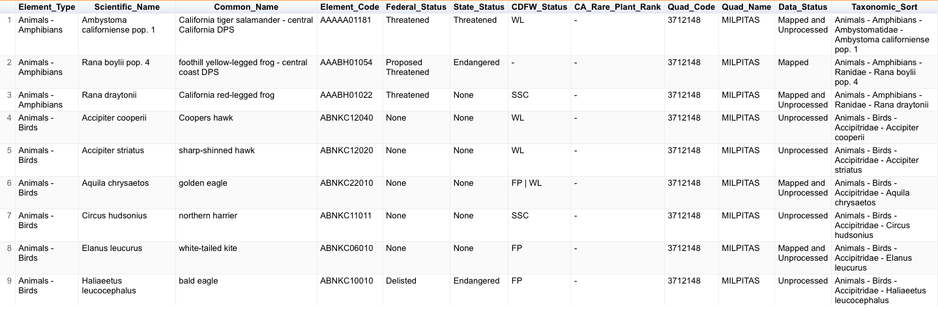
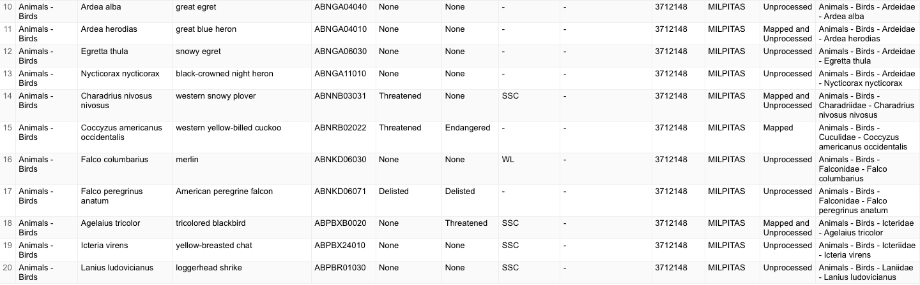
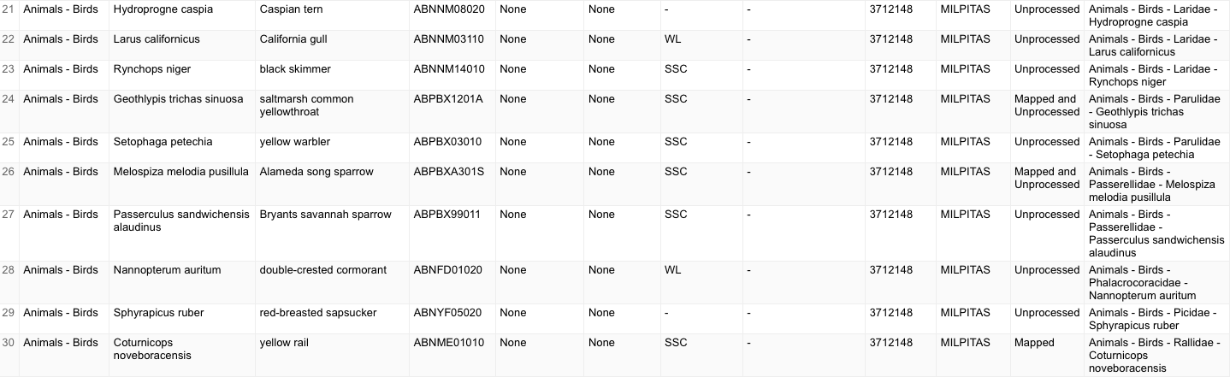
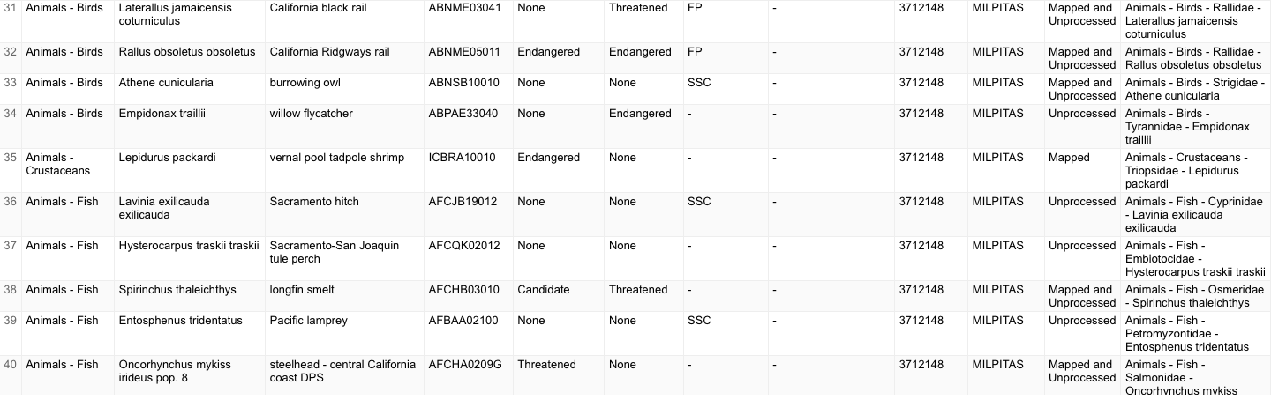
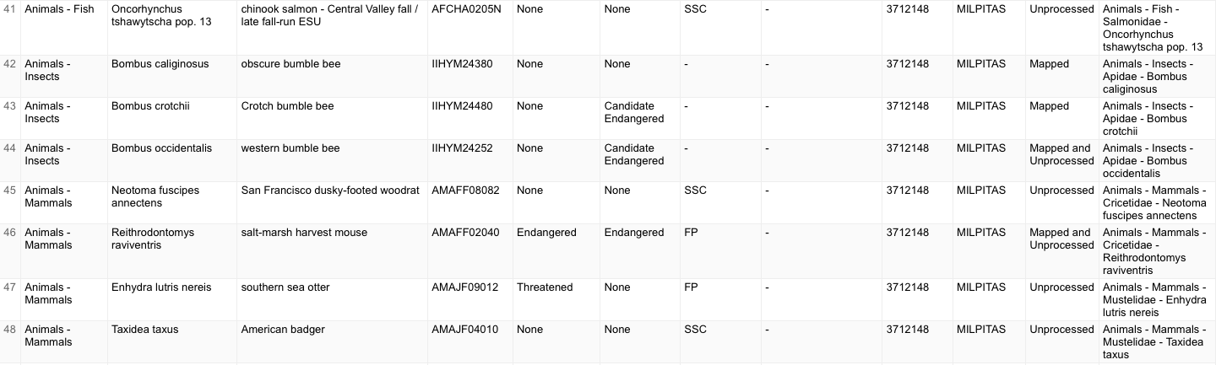
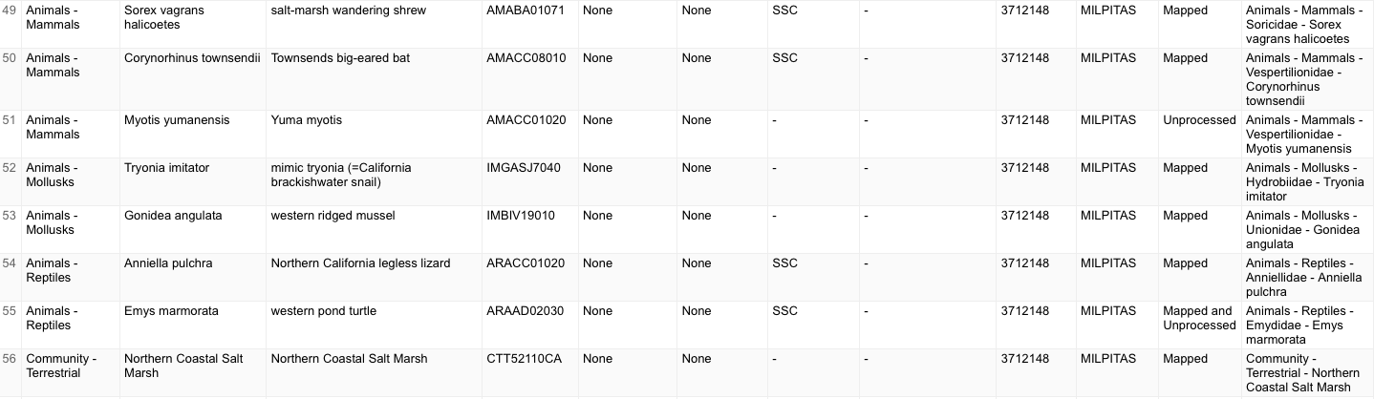
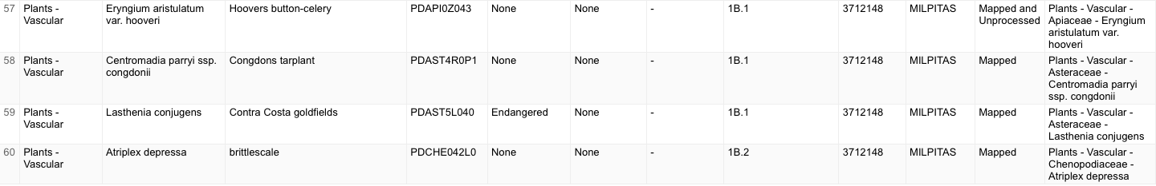
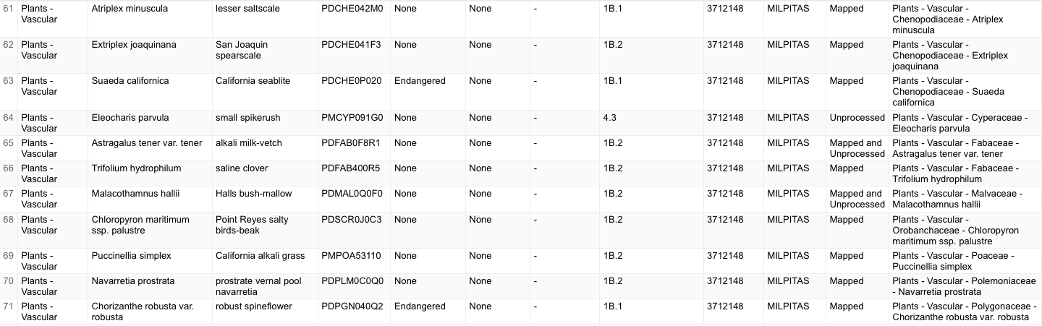
Figure 4. The different species in the project site.

Work Cited:
Bald and golden eagle protection act: U.S. Fish & Wildlife Service. FWS.gov. (n.d.). https://www.fws.gov/law/bald-and-golden-eagle-protection-act
Calflora. (2023). Calflora. Retrieved from Congdon's tarplant: https://www.calflora.org/app/taxon?crn=8896

California Native Plant Society. (2023). Congdon's Tarplant. Retrieved from California Native Plant Society: https://www.cnps.org/

City of San Jose. (1988) Alviso Master Plan. City of San Jose https://www.sanjoseca.gov/home/showpublisheddocument/16053/636681597543870000

City of San Jose. (2022, February). APPENDIX B/Biological Resources and Due Diligence Reports. City of San Jose. Retrieved March 16, 2023, from https://www.sanjoseca.gov/home/showpublisheddocument/85827/637882895862400000.

City of San Jose . (2022, May). Second Harvest Food Bank Warehouse Project Initial Study. San Jose, California.
City of San Jose. (2016). Council Policy 6-34. Retrieved from https://www.sanjoseca.gov/home/showpublisheddocument/12815/636669915138100000

Second Harvest Food Bank Warehouse Project - City of San Jose. (n.d.-b). https://www.sanjoseca.gov/home/showpublisheddocument/85841/637882909267600000

U.S. Fish & Wildlife Service human disturbance of breeding golden ... - FWS. (n.d.). https://ecos.fws.gov/ServCat/DownloadFile/166300

Appendix:
ArcGIS web application. (n.d.). https://www.arcgis.com/apps/webappviewer/index.html?id=6f379e130e9a43ab9dee28806ed2c885&amp;extent=-13574341.156%2C4480904.8205%2C-13559818.1207%2C4490039.0454%2C102100

Csj.maps.arcgis.com. (n.d.). https://csj.maps.arcgis.com/apps/instant/lookup/index.html?appid=ef685f767b484eb6bcfc70f8fb651ef6
Dchiang. (n.d.). Bios6app. https://apps.wildlife.ca.gov/bios6/?tool=cnddbqv
Habitat Agency Geobrowser. (n.d.). http://www.hcpmaps.com/habitat/

